**Employees Table:-**

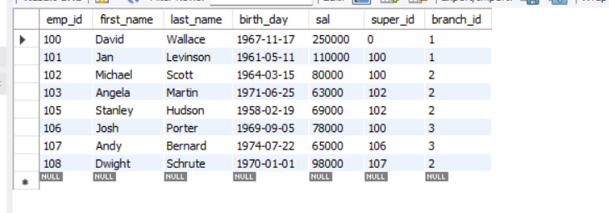

**Query 1**

select count(*) from employees;

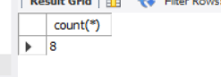

**Query 2**

select count(first_name) from employees;



**Query 3**

select avg(sal) from employees;

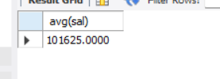

**Query 4**

select sum(sal) from employees;

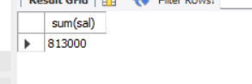

**Query 5**

select max(sal) from employees;

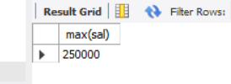

**Query 6**

select min(branch_id) from employees;

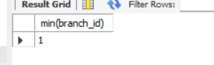

**Query 7**

select sum(sal) from employees group by super_id;

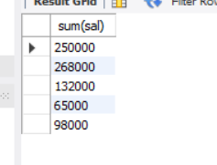

**Query 8**

select sum(sal) from employees group by branch_id;

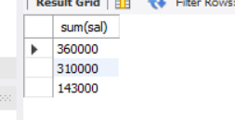

**Query 9**

select avg(sal) from employees group by super_id;

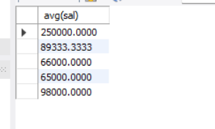

**Query 10**

select avg(sal) as average_salary from employees group by branch_id having avg(sal)>50000;

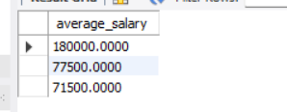

**Query 11**

select count(emp_id) from employees group by branch_id;

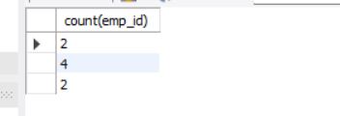

**Query 12**

select sum(sal), super_id, branch_id from employees group by super_id, branch_id;

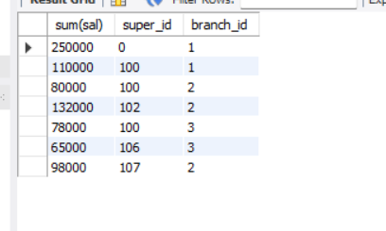

**Query 13**

select sum(sal) from employees group by branch_id order by sum(sal) desc;

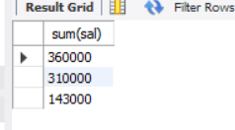

**Query 14**

select round(avg(sal),2) from employees group by super_id;

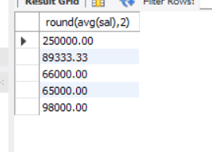

**Query 15**

select emp_id, first_name, last_name from employees group by emp_id order by sal desc limit 1;



**Query 16**

select branch_id, sal from employees e where sal > ( select avg(sal) from employees where branch_id = e.branch_id);

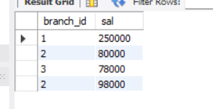

**Query 17**

select branch_id, avg(sal) as avg_salary from employees where sal > 30000 group by branch_id;

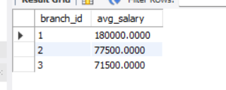

select branch_id, avg(sal) as avg_salary from employees group by branch_id having avg(sal) > 30000;

